Studying the D2 Dopamine Receptor Protein Sequence

- Introduction
- The Dopamine D2 Receptor (DRD2) is a G-protein coupled receptor that plays a critical role in neurotransmission within the central nervous system. It is primarily located in key brain regions, such as the striatum, where it regulates important functions like movement, reward, and motivation
  - Protein Name: D(2) dopamine receptor isoform 3
  - Organism: Homo sapiens
  - Molecule Type: Amino acid
  - Query Length: 442 amino acids
  - Accession Number: NP_001427297.1

- Methodology
I followed these steps to complete the task:
- I searched for the Human Dopamine D2 Receptor (DRD2) in the NCBI database.
- I accessed the FASTA sequence for this protein.
- I used the BLASTp tool to find 10 homologous sequences from different species and compared them to study their similarities.

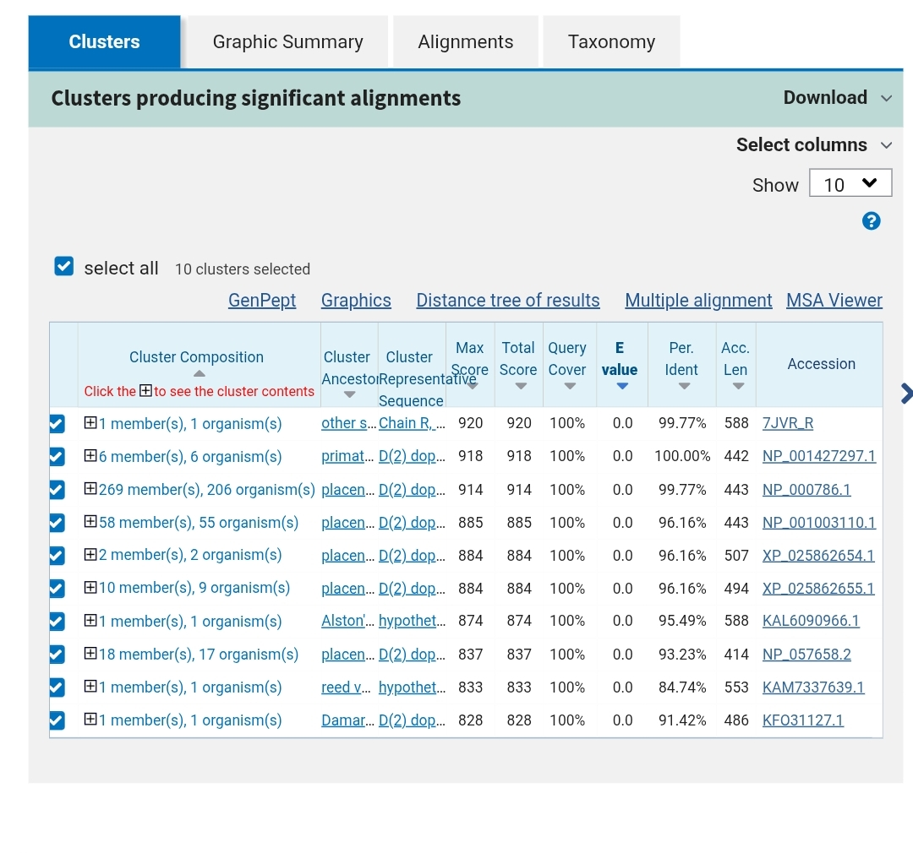
Figure 1: Results of the BLASTp analysis showing the top 10 homologous sequences. The data demonstrates high sequence similarity and conservation of the Dopamine D2 Receptor (DRD2) across different species.

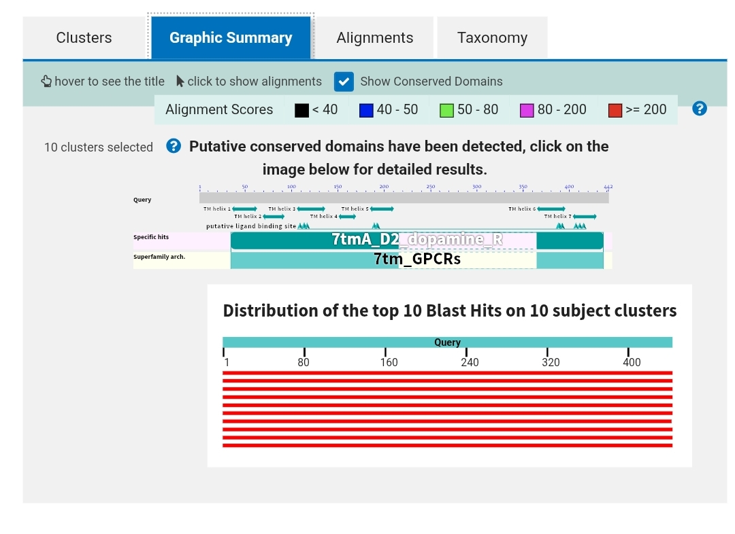
Figure 2: This chart shows the BLAST results for the DRD2 protein. The red bars represent the high similarity between our human protein and the ones found in other species across the whole sequence. It also highlights the '7tm_GPCR' domain, which shows that this protein belongs to the G-protein coupled receptor family.

- Results
Based on the findings:
- The BLAST search identified 10 significant sequences from different species that share high similarity with the human DRD2 protein.
- The Graphic Summary shows strong alignment across the entire protein length, with red bars indicating high-scoring matches.
- The analysis successfully identified the ‘7tm_GPCR’ conserved domain, which confirms that this protein belongs to the G-protein coupled receptor family.
- Appendix
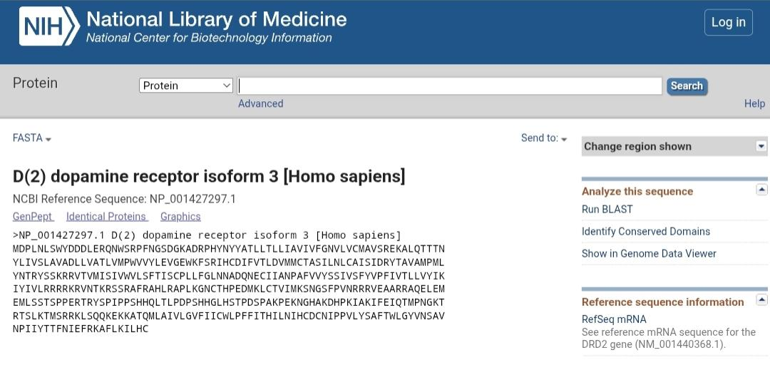
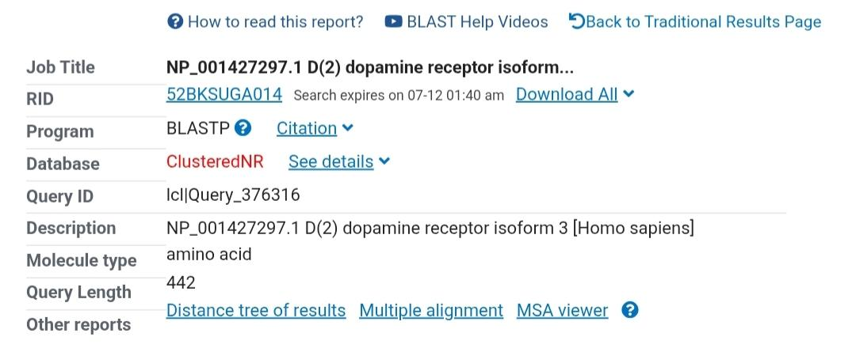
Figure 3: showing FASTA sequence of the human DRD2 protein from the NCBI database

Figure4: BLASTp search summary, including the Job Title, RID, and parameters used for the sequence analysis

- Reference
National Center for Biotechnology Information (NCBI). BLASTp search tool. at: https://blast.ncbi.nlm.nih.gov/ [Accessed July 10, 2026].

